**Assignment – 1**

**Student Name:** Vivek Kumar  **UID:** 21BCS8129

**Branch:** BE-CSE (LEET) **Section/Group:** 809/A

**Semester:** 4th **Date of Performance:** 12/03/2022

**Subject Name:** Principles of AI  **Subject Code:** 20CST-258

**1. Aim/Overview of the practical:**

‘Customers who bought this also bought this…’ we often see this when we shop on Amazon. What is the logic behind recommendation engines?

**2. Task to be done/ Which logistics used:**

* Algorithm Flow chart.
* Steps of Working Principle of the Algorithm.

**3. Theories:**

A product recommendation engine is essentially a solution that allows marketers to offer their customers relevant product recommendations in real-time. As powerful data filtering tools, recommendation systems use algorithms and data analysis techniques to recommend the most relevant product/items to a particular user.

The main aim of any recommendation engine is to stimulate demand and actively engage users. Primarily a component of an eCommerce personalization strategy, recommendation engines dynamically populate various products onto websites, apps, or emails, thus enhancing the customer experience. These kinds of varied and omnichannel recommendations are made based on multiple data points such as customer preferences, past transaction history, attributes, or situational context.

Recommender systems can be used across multiple verticals such as e-commerce, entertainment, mobile apps, education, and more (*discussed in detail later*). In general, a recommendation engine can be helpful in any situation where there is a need to give users personalized suggestions and advice.

**Working of Recommendation Engine:**

One of the crucial components behind the working of a product recommendation engine is the recommender function, which considers specific information about the user and predicts the rating that the user might assign to a product.

Having the ability to predict user ratings, even before the user has provided one, makes recommender systems a powerful tool.

It uses specialized algorithms and techniques that can support even the largest of product catalogues. Driven by an orchestration layer, the recommendation engine can intelligently select which filters and algorithms to apply in any given situation for a specific customer. It allows marketers to maximize conversions and also their average order value.

Typically, a recommendation engine processes data through the below four phases-

* Collection

Data collected here can be either explicit such as data fed by users (ratings and comments on products) or implicit such as page views, order history/return history, and cart events.

* Storing

The type of data you use to create recommendations can help you decide the kind of storage you should use, like the NoSQL database, a standard SQL database, or object storage.

* Analysing

The recommender system analyses and finds items with similar user engagement data by filtering it using different analysis methods such as batch analysis, real-time analysis, or near-real-time system analysis.

* Filtering

The last step is to filter the data to get the relevant information required to provide recommendations to the user. And for enabling this, you will need to choose an algorithm suiting the recommendation engine from the list of algorithms explained in the next section.

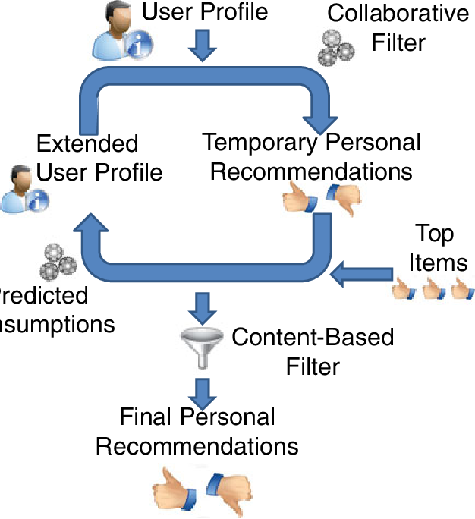**4. Flowchart:**

**Learning outcomes (What I have learnt):**

**1.** Studied about the Recommendations Engine.

**Evaluation Grid (To be created as per the SOP and Assessment guidelines by the faculty):**

|  |  |  |  |
| --- | --- | --- | --- |
| Sr. No. | Parameters | Marks Obtained | Maximum Marks |
| 1. |  |  |  |
| 2. |  |  |  |
| 3. |  |  |  |
|  |  |  |  |